Dudebeet
  - By: Colby Sullivan

Overview
For my DFS I plan to create a roguelike similar to Brotato where the emphasis is item synergy rather than twitchy gameplay. My deep focus will be on the scalable item system and balancing. My gameplay loop will be simple wave-based combat with a UI shop that displays at the end of each round.
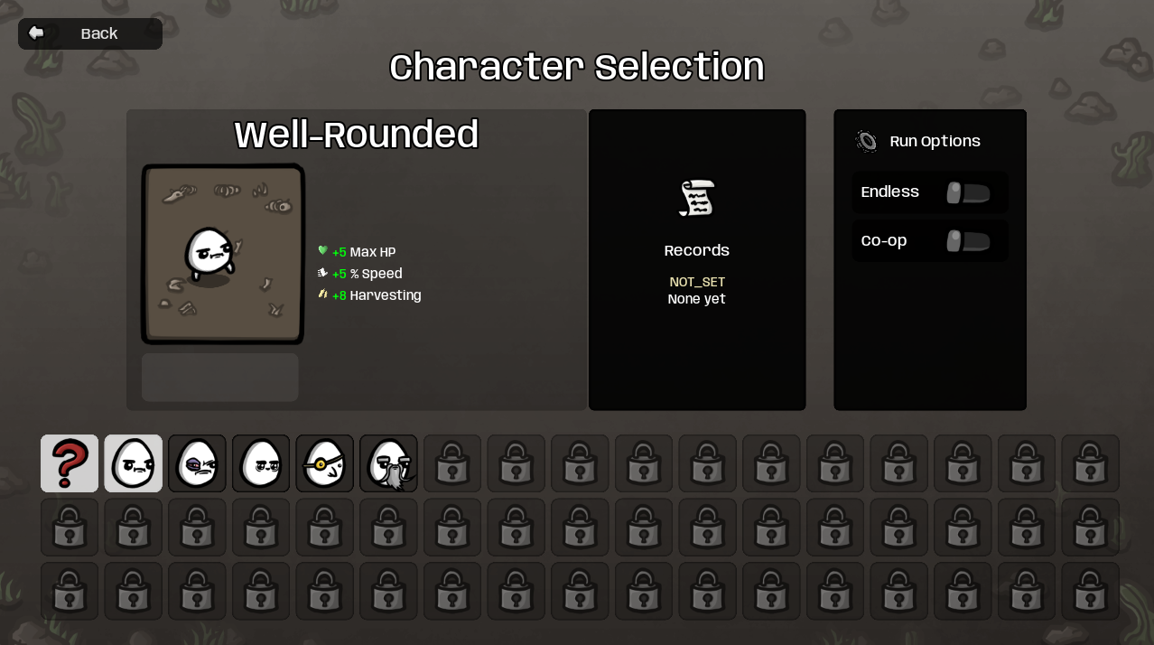
Figure 1 Character selection screen in Brotato

When starting the game, the player can choose one weapon from a restricted list to start the game. Players will also pick from a list of 3 different play types: attack damage, bruiser, and life steal.
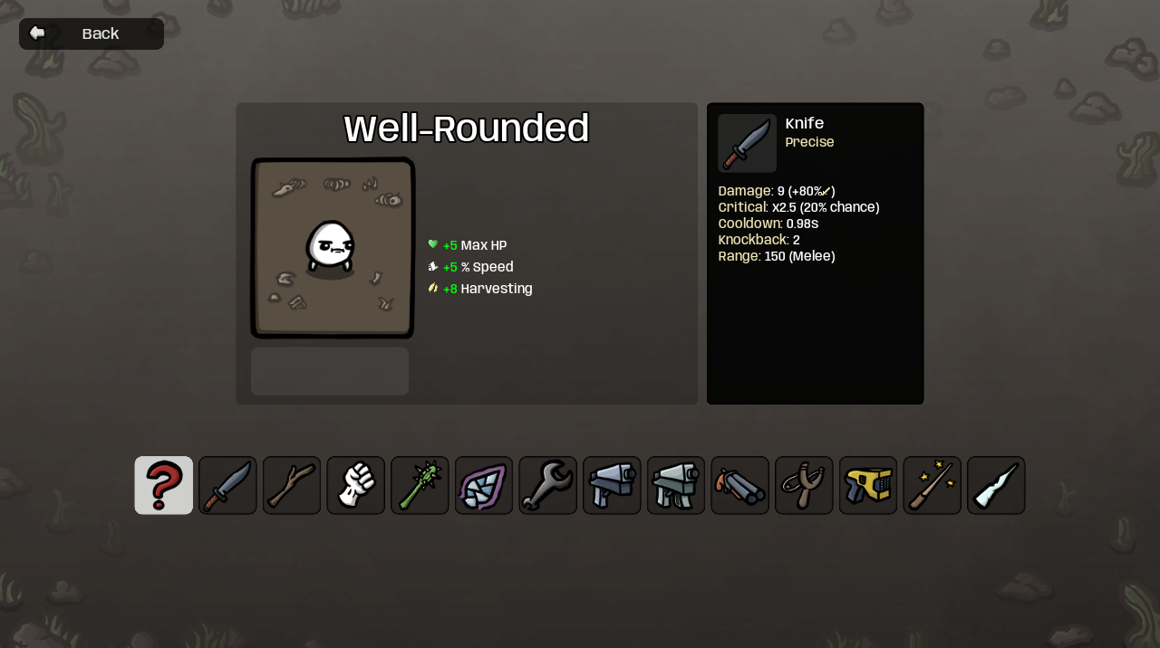
Figure 2 Weapon selection in Brotato

Gameplay Elements & Technical Features

Gameplay loop overview
In-between rounds players will get to choose from a random list of power ups which will give them permanent upgrades without a cost such as coins. After choosing the player can now spend gold that was acquired from the rounds on new items. Items will be one of two things; either a weapon or another weaker powerup. For weapons you can hold up to two and they are upgradable if you buy two of the same weapons.
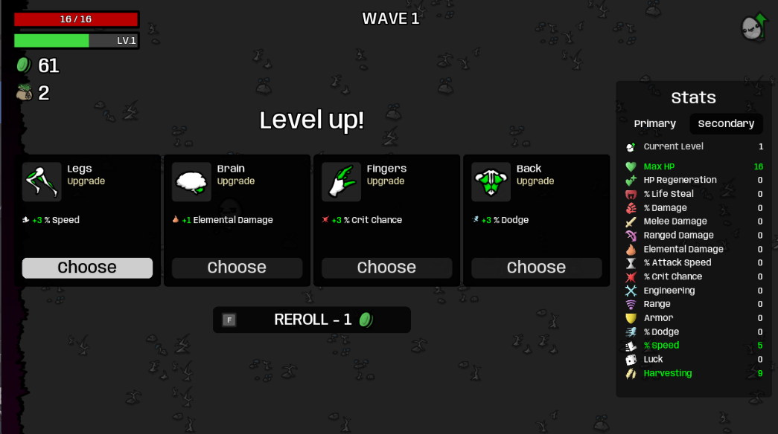
Figure 3 Permanent powerups in Brotato
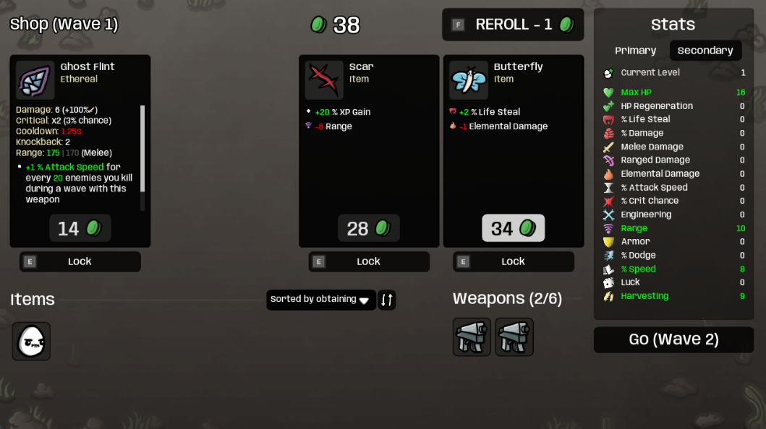
Figure 4 Item shop in Brotato

Items and Upgrades
All items and upgrades will be handled using XML. Items and upgrades will be very similar where they will interact with similar categories, but the main difference is that upgrades are free and they are inherently more powerful and items are bought in the shop. Actor definitions will simply just be base actors with preset upgrades and downgrades using the item system.
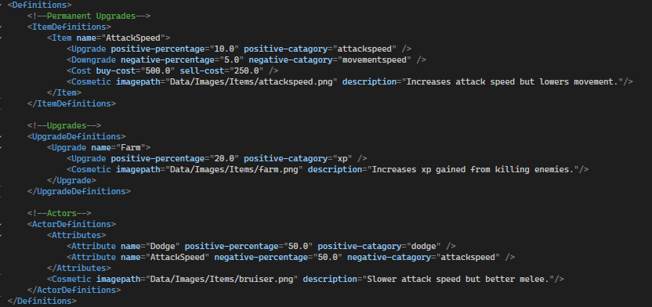
Figure 5 XML for items, upgrades, and actor definitions

Item UI
I plan to implement a new engine system that will handle my mouse input which will be used for various sections of the main menu and upgrade screens. I have a first past version that I implemented in Doomenstein but it was far too hacky, and I want the buttons to be mapped to specific bounding boxes that react with mouse hovers.

Combat
Combat will include two different types of enemies with various armor types. One being melee which will include higher attack and magic armor and the other being ranged

